CECIL COUNTY RETIRED
SCHOOL PERSONNEL
ASSOCIATION
2019-2020
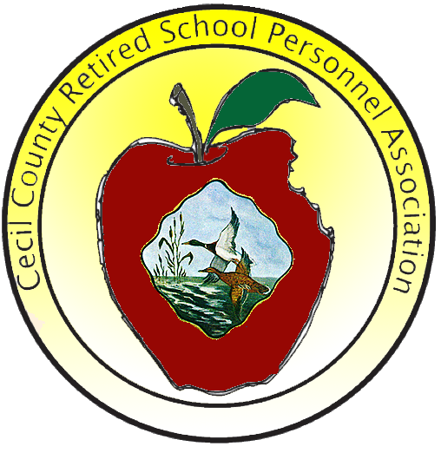

DIRECTORY OF OFFICERS
AND
EXECUTIVE COMMITTEES
Miscellaneous Information

Revised – July 31, 2026
The Cecil County Retired School Personnel Association (CCRSPA) is affiliated with the Maryland Retired School Personnel Association (MRSPA). The purpose is to improve the general welfare of Cecil County Public School retirees. Membership in the organization is open to all retired teachers, administrators, supervisors, paraprofessionals, and supporting services staff.

CCRSPA activities include:

- Disseminate information on timely issues such as health benefits and legislation
- Distribute quarterly CHALKBOARD newsletters each year
- Host quarterly luncheon meetings each year
- Award grants to staff to enrich students experiences
- Award scholarships to future educators
- Collect canned goods for local food pantries
- Promote volunteer opportunities that serve our community
- Collect apparel for kids annual drive
- Social excursions to interesting sites
- Maintain a retiree website that is listed below

http://CecilRSPA.org
Tuesday Luncheon Meetings are held in the following months.
March May
September December
Plan to arrive at Luncheon Meetings at 11 to have time to share your adventures with friends.
The Chalkboard Deadlines
Winter Issue - February 1st
Spring Issue - April 1st
Fall Issue - August 1st
Holiday Issue - October 1st
Articles, news, or notices from members are encouraged. Please submit by US Mail or email to:
Gretchen M. Ginder -- Chalkboard1@CecilRSPA.org

Signe Mika -- Chalkboard2@CecilRSPA.org

In the Event of illness, hospitalization, death, or other significant event concerning any member or non-member who has retired from the Cecil County Public School system, please notify the Sunshine Committee Member for your area so an appropriate card may be sent.

MRSPA is the only organization in the state working exclusively for retired school personnel. The retiree member of the Board of Trustees of the Maryland State Retirement and Pension System (MSRPS) is on the MRSPA Board of Directors. We monitor each meeting of the MSRPS board. We review each bill introduced in the Maryland General Assembly and take positions on those that support or oppose our legislative priorities.

http://www.mrspa.org/

President
Mary Ellen Butkiewicz
President@CecilRSPA.org

Past-President
Anne Humphrey
Past-President@CecilRSPA.org

Corresponding Secretary
Joan-Marie Parker
Corresponding_Secretary@CecilRSPA.org

Recording Secretary
Signe Mika
Recording_Secretary@CecilRSPA.org

Treasurer
Tony Mattern
Treasurer@CecilRSPA.org

Benefits
Paul Humphrey
Benefits@CecilRSPA.org

Communications
Shirley Montgomery
Communications@CecilRSPA.org

Community Outreach
Paula Cobb
Community_Outreach@CecilRSPA.org

Constitution
Kathleen Mullen
Constitution@CecilRSPA.org

Nominating
To be appointed

Legislation Chair
Linda Elwood
Legislation_Chair@CecilRSPA.org

Membership & Pre-Retirement
Sherry Lewis
Membership@CecilRSPA.org

Program
Mary McCleary
Program@CecilRSPA.org

Scholarship & Grants
Charlene Metzger
Scholarship@CecilRSPA.org

Publications &Public Relations Co-Chairs
Gretchen Ginder
Publications@CecilRSPA.org

Public_Relations@CecilRSPA.org

Chalkboard Newsletter
Gretchen Ginder
Chalkboard1@CecilRSPA.org

Signe Mika
Chalkboard2@CecilRSPA.org

Social

Social@CecilRSPA.org

Consumer Education & Protective Services
Consumer_Education@CecilRSPA.org
Sunshine
Debbie Pasco
Sunshine@CecilRSPA.org

Travel
Fred Metzger
Travel@CecilRSPA.org

Website
Tony Mattern
Webmaster@CecilRSPA.org



Cecil County RSPA

For more information mail:
Cecil County RSPA
201 Booth Street
Elkton, MD 21921

